TEAM ID | SWTID –2026- 5976
PROJECT TITLE | Visualizing housing market trends: an analysis of sale prices and features using tableau
MAX MARKS | 3 MARKS

6.3 – Data Preparation
SHEET TITLE | SHEET TYPE
Count of Transformed Housing Data | Table text
Average Sale Prices | Vertical bar chart
Area of House from Basement(in Sqft) | Horizontal bar chart
Total Sales by Years Since Renovation | histogram
Distribution of House Age by Renovation Status | Pie chart
House Age Distribution by Number of Bathrooms, Bedrooms, and Floors | Stacked bar chart

Sheet 01: - Count of Transformed Housing Data
Step 1: Drag and Drop Measure Names to Rows
Step 2: Drag Measure Values to Text in Marks Card
Step 3: Drag measure names to details in marks card
- Measures values under mark card remove all values except cnt(transformed housing data) sum(are of the house from basement ) avg (sales price)
Step 4: for color and borders go to format in menu tab

Output:
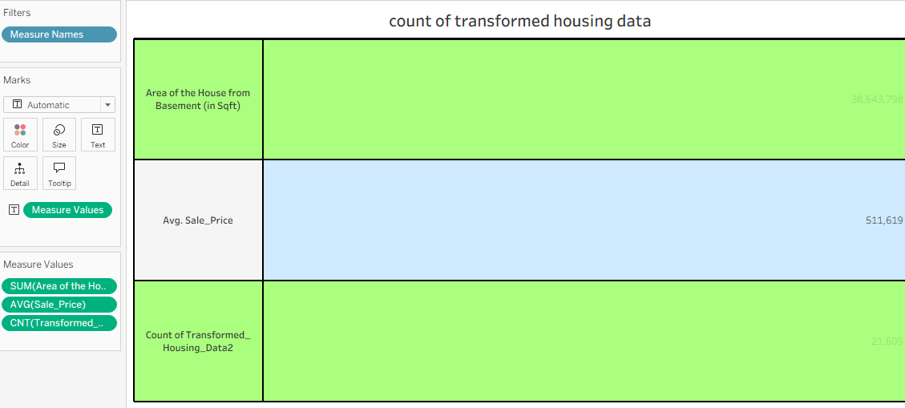

Sheet 2: average sales prices
Step 1:drag sale price to rows
a.and convert to sum then change to (avg sale price)
step 2:drag measure name to columns
step 3:in marks card select “bar”
step 4:choose any color in mark card
step 5:click table on marks card
a.tick the check box show mark tables
step 6:right click y-axis
a.click format choose currency (custom) then display unit (k)and decimal places:0
output: 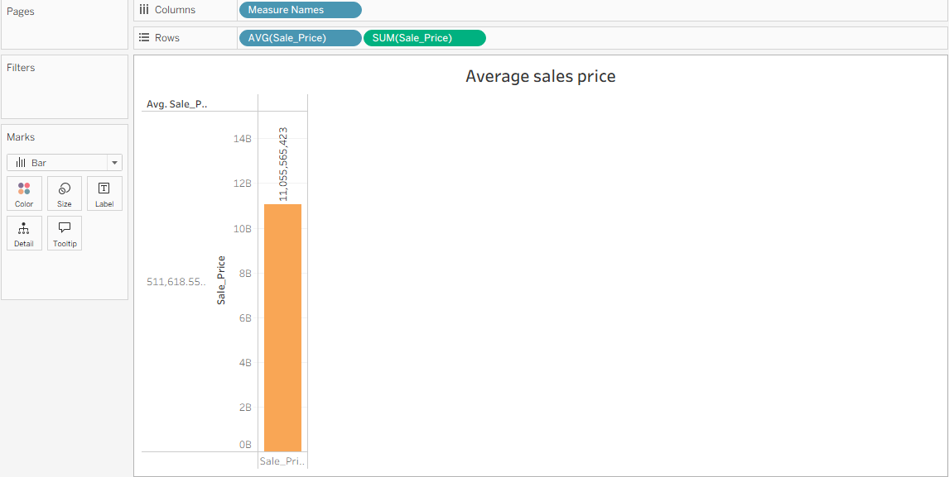

Sheet 3: Area of House from Basement(in Sqft)
Step 1:drag basement area to column .
a.the basement area to sum (basement area)
step 2:drag measure name to rows
step 3:drag measure names to lable in marks card
step 4:drag measure values to details in marks card
A.remove all values expect sum(area of house from basement)and sum(basement area) in the marks card.

Output: 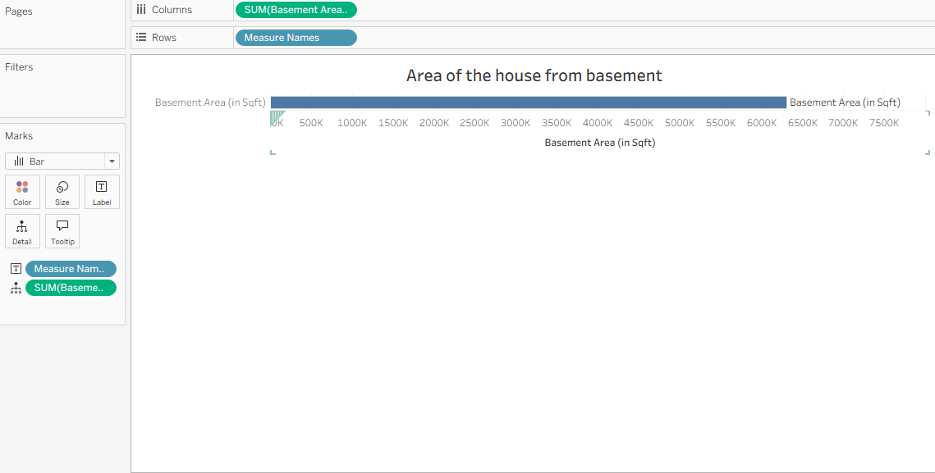

Sheet 4: Total Sales by Years Since Renovation
Step 1:drag sale price (bin)to column
Step 2:drog the sale price to rows An convert to CNT(sales price)
Step 3:drag the sale price(bin) to filters
Step 5:and final step is drag the sum(year since renovation) to table.
Output: 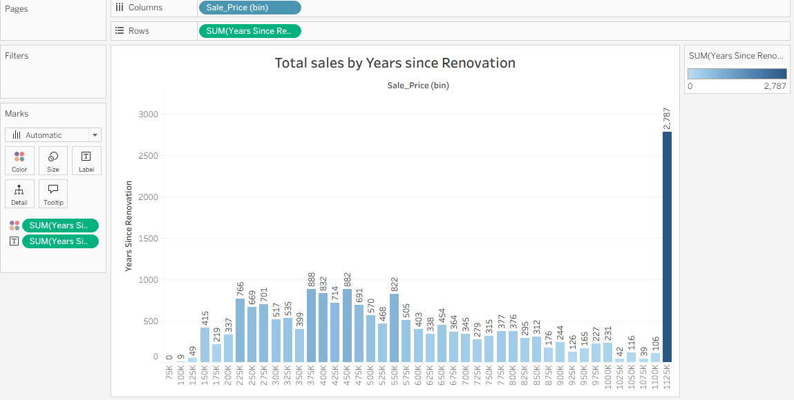

Sheet 5: distribution of house age by renovation status
Step 1:drag the age of house (in years)and drop filters
A.then you change the range should be from 1 to 10
Step 2:drag age of house (in year)drop on colors in the marks card
Step 3:drag area of the house from basement (in sqft) angle in marks card and convert to sum
Step 4:drag basemet are (in sqft)to size on marks card
Step 5:drag area of house (in years) drop on table
Step 6:clicl on colors in marks card and set colors.
Output: 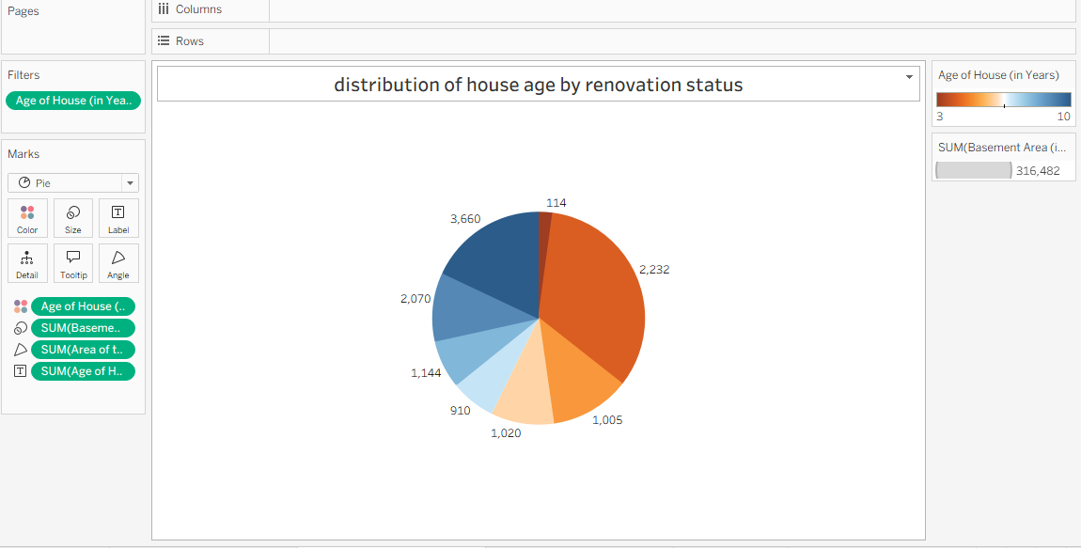

Sheet 6: House Age Distribution by Number of Bathrooms, Bedrooms, and Floors
Step 1:drag age of house (in years) to columns
Step 2:drag the measures names to columns side of age of house(in year)
Step 3:drag measure values to rows
Step 4:then we drop measure values in rows it automatically generates measures values in the marks card on the time you remove all values expact sum (no.of bathrooms)and sum (no.of bed rooms) and finally sum(no.of floors)
Step 5: drop measures name to colors in mark card
Output: 